# **Name: Abdurrahman Qureshi**

# **Roll No: 210451**

Practical No: 18

1) Write a Program to create an Edit Text and a Button “Click here to Visit”. When you enter an URL and press button it should open the specific URL page.

JAVA CODE:

package com.example.mad_playground;  
  
import android.content.Intent;  
import android.net.Uri;  
import android.os.Bundle;  
import android.util.Log;  
import android.view.View;  
import android.widget.Button;  
import android.widget.EditText;  
  
import androidx.appcompat.app.AppCompatActivity;  
  
public class MainActivity extends AppCompatActivity {  
 String LifeCycle = "My Main Activity LifeCycle";  
 @Override  
 protected void onCreate(Bundle savedInstanceState) {  
 super.onCreate(savedInstanceState);  
 setContentView(R.layout.*activity_main*);  
 Log.*d*(LifeCycle, "onCreate() ---> called");  
 EditText url = findViewById(R.id.*url*);  
 Button button = findViewById(R.id.*button*);  
 button.setOnClickListener(new View.OnClickListener() {  
 @Override  
 public void onClick(View view) {  
 Intent intent = new Intent(Intent.*ACTION_VIEW*);  
 intent.setData(Uri.*parse*(*url*.getText().toString()));  
 startActivity(intent);  
 }  
 });  
 }  
}

OUTPUT:

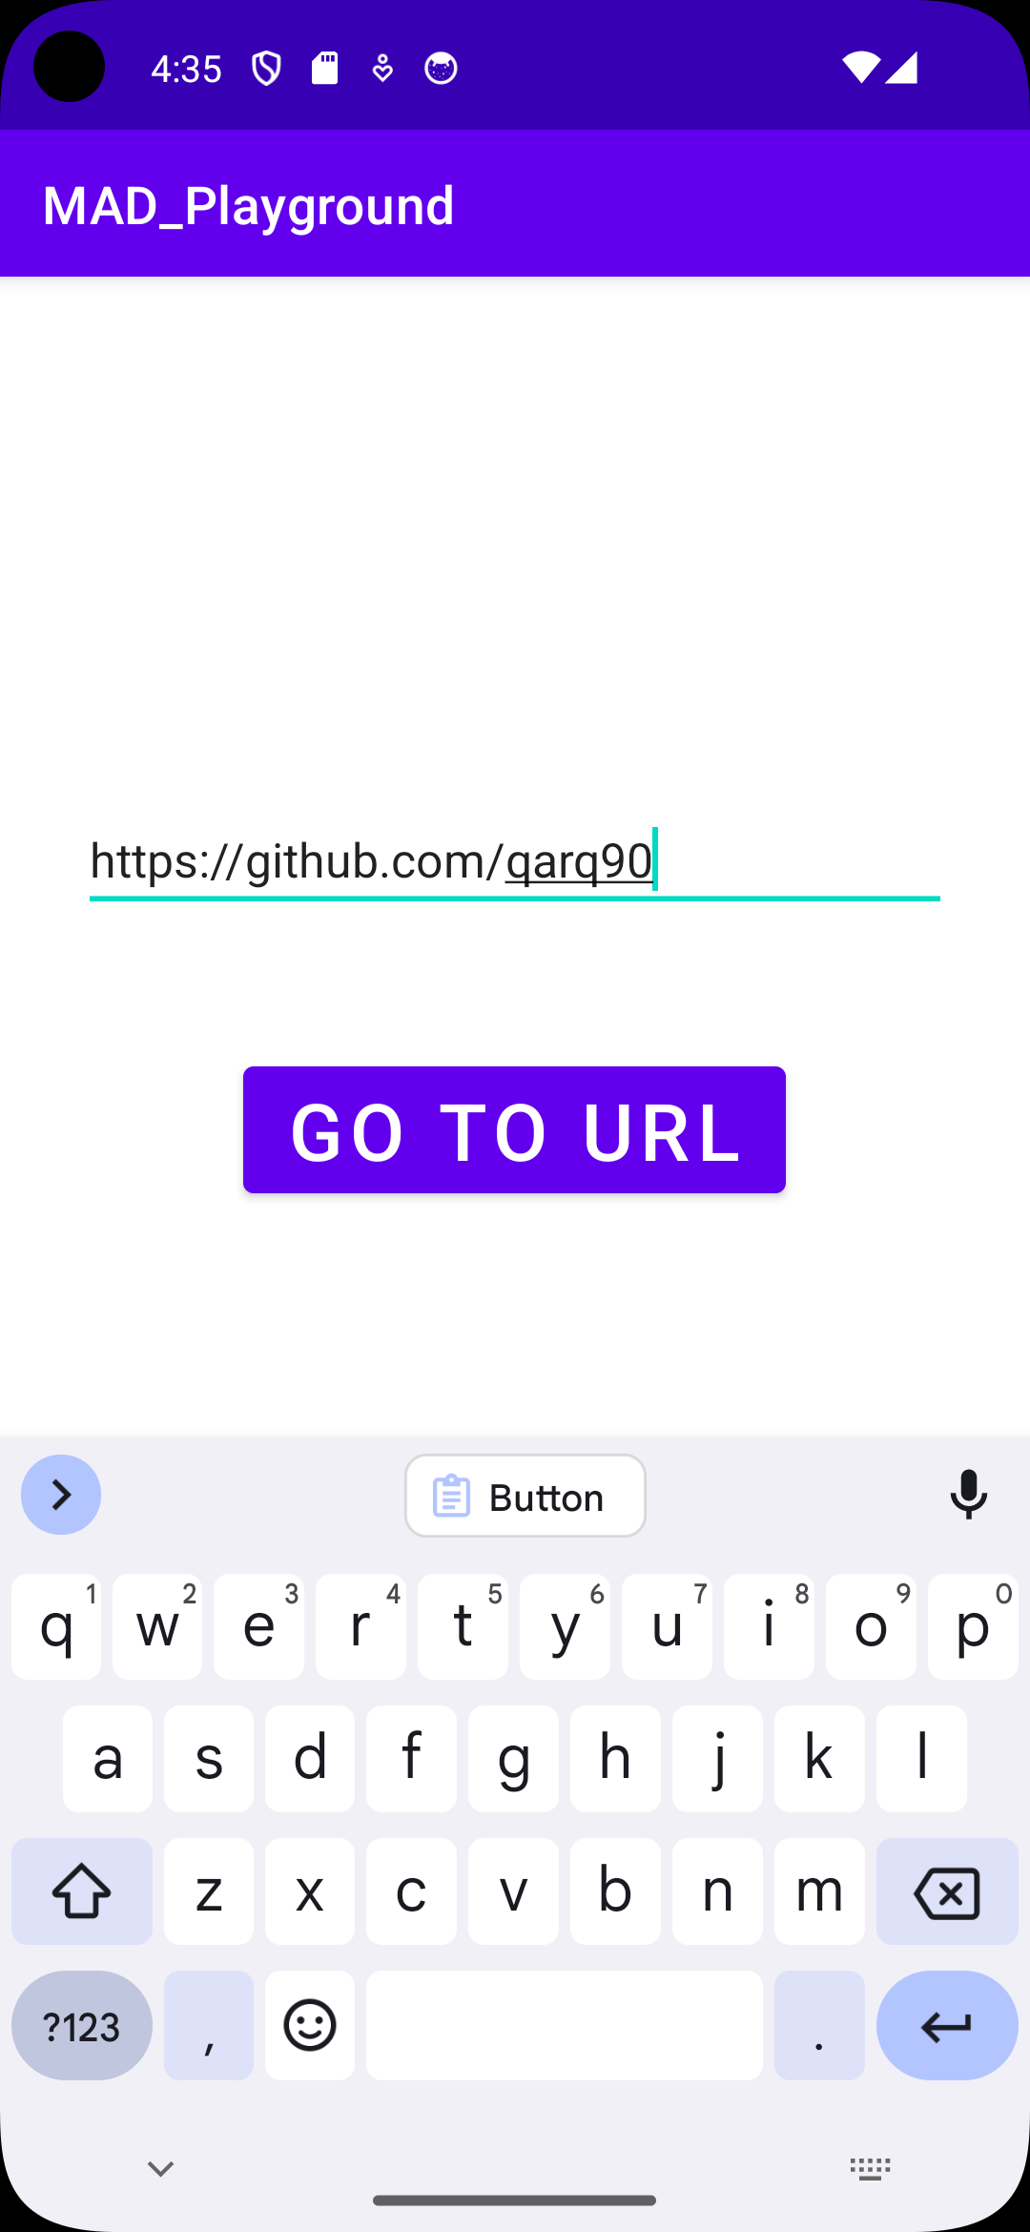 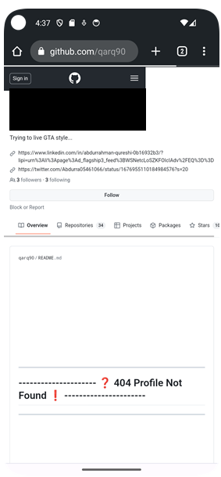

2) Open dialler on click of a button

JAVA CODE:

package com.example.mad_playground;  
  
import android.content.Intent;  
import android.net.Uri;  
import android.os.Bundle;  
import android.util.Log;  
import android.view.View;  
import android.widget.Button;  
  
import androidx.appcompat.app.AppCompatActivity;  
  
public class MainActivity extends AppCompatActivity {  
 String LifeCycle = "My Main Activity LifeCycle";  
 @Override  
 protected void onCreate(Bundle savedInstanceState) {  
 super.onCreate(savedInstanceState);  
 setContentView(R.layout.*activity_main*);  
 Log.*d*(LifeCycle, "onCreate() ---> called");  
 Button button = findViewById(R.id.*button*);  
 button.setOnClickListener(new View.OnClickListener() {  
 @Override  
 public void onClick(View view) {  
 Intent intent = new Intent(Intent.*ACTION_DIAL*);  
 startActivity(intent);  
 }  
 });  
 }  
}

OUTPUT:

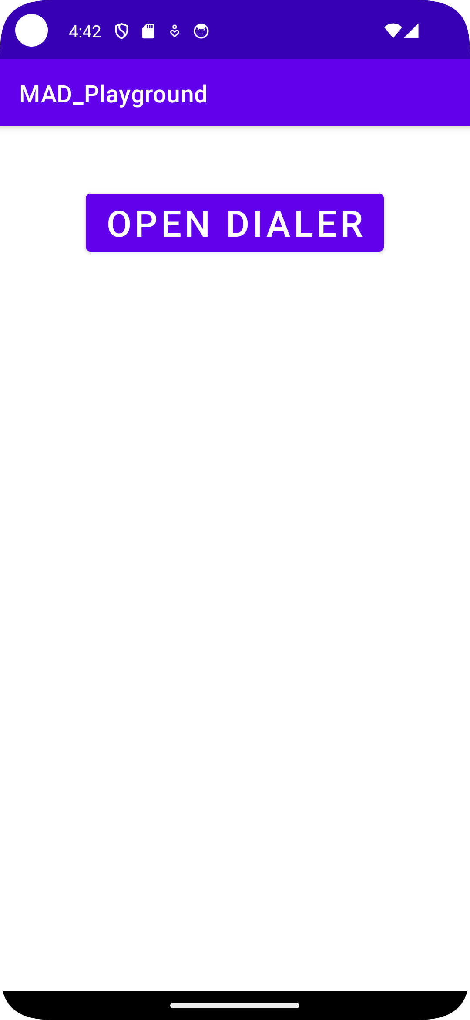 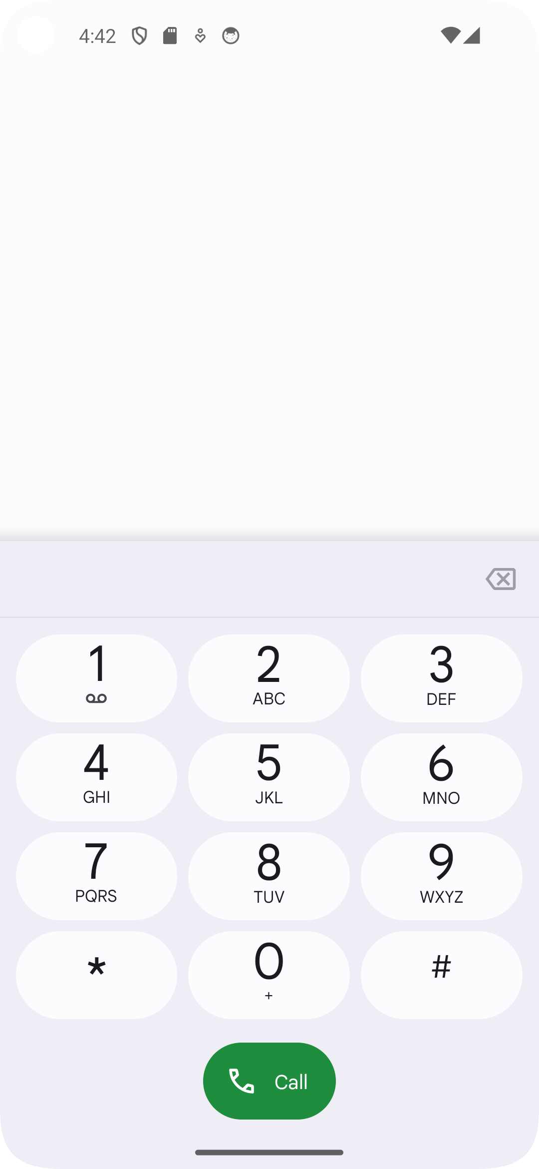

2) Generate and display factorial in another activity

MainActivity.java

package com.example.mad_playground;  
  
import android.content.Intent;  
import android.net.Uri;  
import android.os.Bundle;  
import android.util.Log;  
import android.view.View;  
import android.widget.Button;  
import android.widget.EditText;  
  
import androidx.appcompat.app.AppCompatActivity;  
  
public class MainActivity extends AppCompatActivity {  
 String LifeCycle = "My Main Activity LifeCycle";  
 @Override  
 protected void onCreate(Bundle savedInstanceState) {  
 super.onCreate(savedInstanceState);  
 setContentView(R.layout.*activity_main*);  
 Log.*d*(LifeCycle, "onCreate() ---> called");  
 EditText num = findViewById(R.id.*num*);  
 Button button = findViewById(R.id.*button*);  
 button.setOnClickListener(new View.OnClickListener() {  
 @Override  
 public void onClick(View view) {  
 Intent intent = new Intent(getApplicationContext(), second_activity.class);  
 intent.putExtra("num", Integer.*parseInt*(*num*.getText().toString()));  
 startActivity(intent);  
 }  
 });  
 }  
}

second_activity.java

package com.example.mad_playground;  
  
import androidx.appcompat.app.AppCompatActivity;  
  
import android.content.Intent;  
import android.os.Bundle;  
import android.widget.TextView;  
  
public class second_activity extends AppCompatActivity {  
  
 @Override  
 protected void onCreate(Bundle savedInstanceState) {  
 super.onCreate(savedInstanceState);  
 setContentView(R.layout.*activity_second*);  
 TextView text = findViewById(R.id.*text*);  
 Intent intent = getIntent();  
 int num = intent.getIntExtra("num", 1);  
 int fact = 1;  
 for(int i = 1; i<=num; i++) {  
 fact = fact * i;  
 }  
 text.setText("Factorial of "+ num +" is "+ fact);  
 }  
}

OUTPUT:

